Online Marketing Concept
Tasks
1.
Pick any two apps you use daily (like Instagram, Zomato, or Flipkart) and identify one online marketing technique each app uses to attract new users. Write a short explanation (2-3 lines) for each technique.
2.
Create a simple digital flyer (image or PDF) for a new food delivery app launch, highlighting at least three online marketing concepts such as referral codes, limited-time offers, or influencer shoutouts.<br><br><em><strong>Hint:</strong> Use Canva or any free online design tool to make your flyer look engaging.</em>
3.
List five types of online ads you’ve seen while using YouTube, Instagram, or any other app. For each, mention which platform you saw it on and what made it noticeable or skippable.
4.
Imagine you are launching a new playlist feature for a music app like Spotify. Write a short plan (5-6 lines) describing how you would use online marketing concepts (SEO, social media posts, email campaigns, influencer partnerships) to promote this feature.

(1).
S.No. | App Name | Online Marketing Technique | Explanation (2–3 Lines)
1 | Instagram | Influencer Marketing | Instagram collaborates with influencers and content creators to promote features and brands. Their posts and videos encourage new users to download and actively use the app.
2 | Zomato | Referral Program | Zomato offers discounts and rewards when users invite friends to join the app. This helps attract new users while increasing customer engagement and app downloads.

(2). The digital flyer has been created for your assignment. It includes the required online marketing concepts:
- ✅ Referral Code (Refer & Earn)
- ✅ Limited-Time Offer (50% OFF)
- ✅ Influencer Shoutouts
- ✅ Attractive food images
- ✅ App download section
- ✅ Call-to-Action (Download Now)
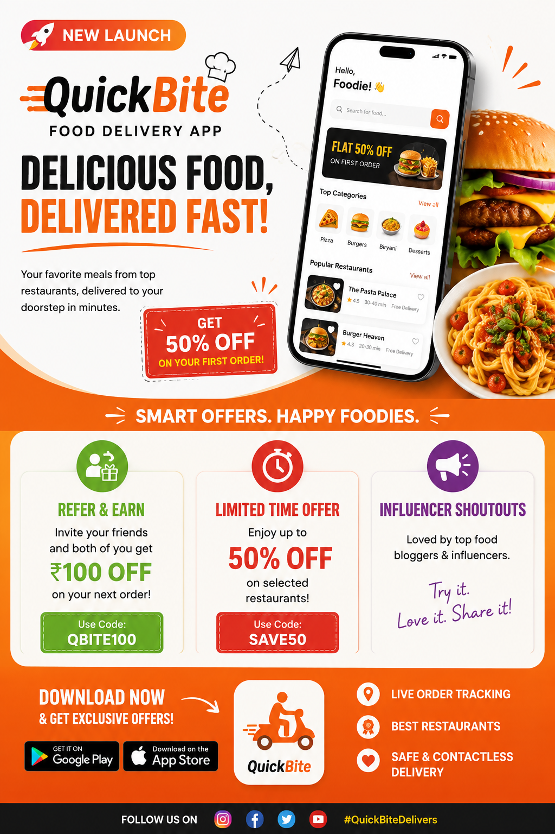

(3). Five Types of Online Ads Seen on Different Platforms
S.No. | Type of Online Ad | Platform | What Made It Noticeable or Skippable
1 | Skippable Video Ad | YouTube | It appears before or during a video and can be skipped after 5 seconds if the user is not interested.
2 | Sponsored Feed Post | Instagram | It blends with regular posts but is labeled "Sponsored" and uses attractive images or videos.
3 | Story Ad | Instagram | It appears between users' stories in full-screen format and can be skipped by swiping to the next story.
4 | Banner Display Ad | Mobile Apps & Websites | It is displayed at the top or bottom of the screen and is easy to notice because of its colorful design and call-to-action.
5 | In-Feed Product Ad | Facebook | It appears while scrolling through the news feed and includes product images, prices, and a "Shop Now" button to attract users.

(4). Online Marketing Plan for a New Playlist Feature
- Optimize the feature page with SEO-friendly keywords like "best music playlists" and "create custom playlists" to attract search traffic.
- Share engaging social media posts on Instagram, Facebook, and X with short videos showing how users can create and share playlists.
- Send an email campaign to existing users announcing the new feature with a "Create Your First Playlist" call-to-action.
- Partner with music influencers and content creators to showcase their favorite playlists and encourage followers to try the feature.
- Offer a limited-time challenge where users who create and share playlists can win premium subscriptions, increasing engagement and app downloads.

